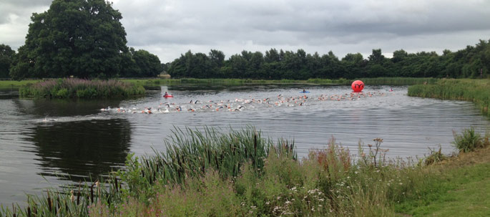

##### **Where can it take you?**



## **How to get sign up?**

Last year saw the first ever Open Water Development camp in Shropshire. It was a huge success with many swimmers either learning or developing their understanding of Open Water swimming.

As a County we had a bigger turn out than ever at the Regional Open Water Championships and also saw two National gold medals won from swimmers who attended the camp last year.

Please contact the following email address provided:

Childs234@btinternet.com

## Open water swimming, like the pool has a National championships, International competitions and is at the Olympics!!!

## **Shropshire County 2020 Open Water Development camp**

Open water swimming has been an exponentially growing sport in the UK over the last 10 years with more and more people trying it out.

Swimmers, triathletes and many more have taken to competing in open water events.

Have you ever thought about trying Open Water Swimming?

Open water swimming

Open water swimming

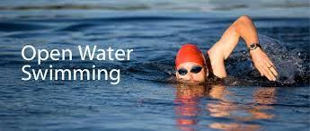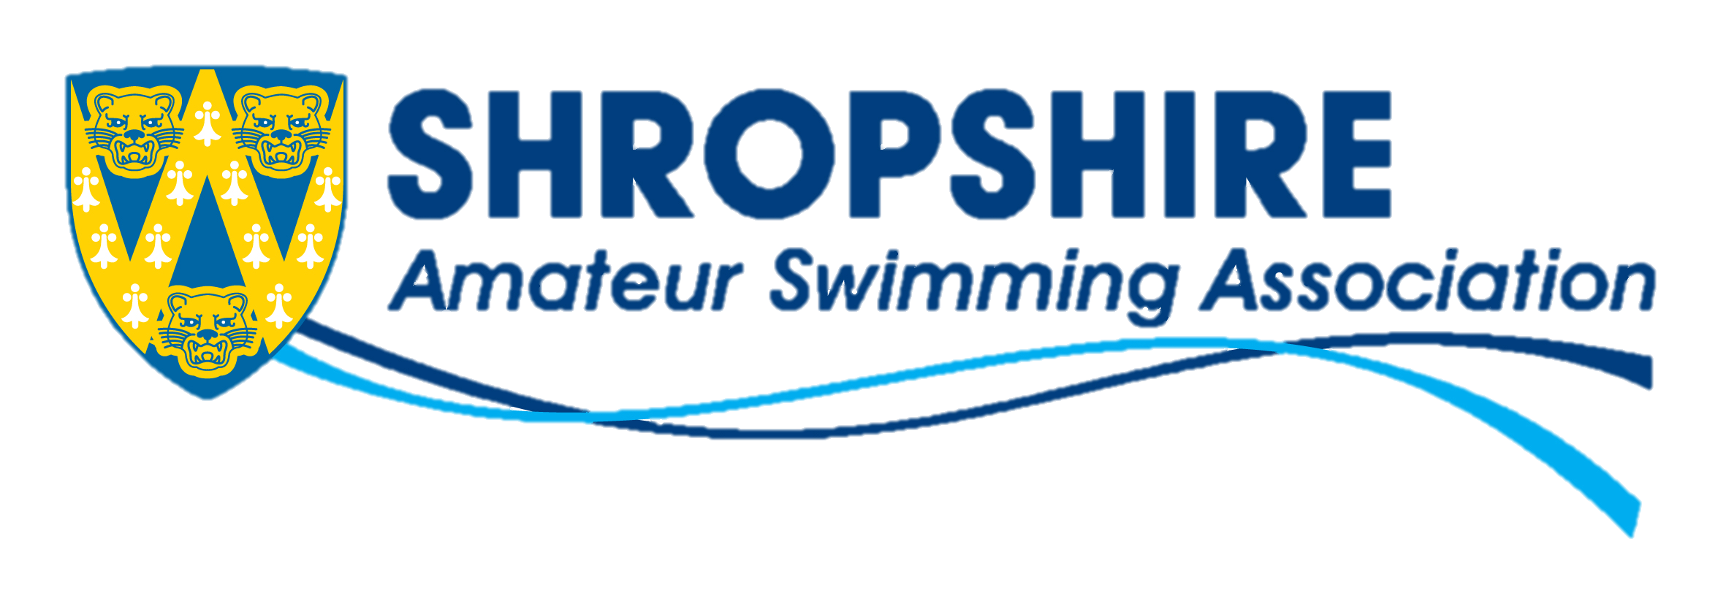

There are plenty of benefits to open water swimming however here is a list of just a few:

* Great way to build fitness and contribute to a healthy lifestyle.
* Great way to meet new people with similar interests.
* Another swimming route to progress along the England talent pathway.
* Get to race in different and beautiful settings around England and all over the world.
* Gives you a chance to get out of the pool and experience something different.

### Benefits of open water swimming

Development camp info:

Shropshire County following the success of the previous years camp will once again be holding an Open Water Development camp for 2020.

The camp is not just for the swimmers but is open to parents, coaches and officials who are interested in open water swimming and want to learn more about the sport.

Wetsuits are not mandatory however you are more than welcome for your child to bring one.

The camp will run on the 6 & 7th June 2020, with the Saturday being a pool session at Ellesmere College and the Sunday will take place at Alderford lake, SY13 3JQ.

Camp coordinators

Jean Childs/Amanda Swan

Lead coaches

Danny Proffitt/Sam Holland